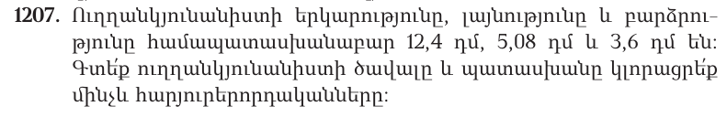
 |  |  | 1 | 2 | 4
x |  |  | 5 | 0 | 8
 |  |  | 9 | 9 | 2
 |  | 0 | 0 | 0
 | 6 | 2 | 0
 | 6 | 2 | 9 | 9 | 2
12,4 x 5,08 = 62,992
 |  |  | 6 | 2 | 9 | 9 | 2
x |  |  |  |  |  | 3 | 6
 |  | 3 | 6 | 7 | 9 | 5 | 2
+ | 1 | 8 | 8 | 9 | 7 | 6
 | 2 | 2 | 5 | 7 | 7 | 1 | 2
62,992 x 3,6 =225,7712
225,7712 ≈ 225,7700 = 225,77

10000 – 999 = 9001

50 x 25 = 1250
1250 : 100 = 12,5

12,5 x 20 = 250
250 / 100 = 2,5
12,5 – 2,5 = 10

50-ից փոքր
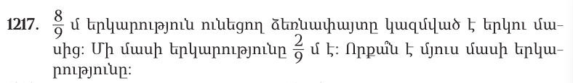
8/9 – 2/9 = 6/9

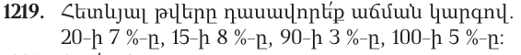
100-ի 5%, 90-ի 3%, 20-ի 7%, 15-ի 8%։

